Year 11 Mathematics-Specialist
Unit 2 Test 2 - Matrices

Unit 2 Test 2 – Part One
Time Allowed : 25 minutes

Student Name : _______________________________________

This task comprises two sections

Part One – Resource Free
Part One contains 5 questions worth 27 marks

Question 1 4 marks

(a) If determine

(i) 2PQ (2)

(ii) QP – P (2)

Question 2 6 marks

Let A,B and C be 2 arbitrary matrices, and

Write T (True) and F (FALSE) for each of the following equations:

a) AB-BA=0 b) AI –IA = 0
FALSE TRUE

c) (A+B)² = A² + B² d) AO = O

FALSE TRUE

e) (AB)⁻¹ = A⁻¹B⁻¹ f) (AB)C = A(BC)

FALSE TRUE

Question 3 9 marks

Square matrices X, Y and Z are such that XY=Z.

a) Express matrix Y in terms of matrices X and Z. (1)

XY = Z
X⁻¹ XY = X⁻¹ Z
Y = X⁻¹ Z

b) Hence or otherwise, determine a 2x2 matrix Y if matrices X and Z are as shown below.
(3)

c) Show that the determinant of XZ is equal to the product of the determinant X and determinant Z i.e. det XZ = det X . det Z (5)

Question 4 6 marks

Let A = , B = , C =

(a) In the product matrices below, fill in the missing entries [ ] with the correct values.

(i) AC = (2)

(ii) CB = `(2)

(b) Is it possible to find two matrices X and Y such that XY is defined but YX is undefined? Justify your answer. (2)

YES

The above example shows C_{3x2}B_{2x2} is possible but B_{2x2}C_{3x2} is not as the columns in the first matrix must be the same as the rows in the second matrix

Question 5 2 marks

By considering the geometrical effects the following transformations have on the points (1,0) and (0,1), state the matrix representing
a) reflection about the y-axis b) rotation of 180° about the origin.

Year 11 Mathematics-Specialist
Unit 2 Test 1 - Matrices

Unit 2 Test 2 – Part Two
Time Allowed : 35 minutes

Student Name : _______________________________________

Part Two – Calculator & Notes Allowed
Part Two contains 6 questions worth 38 marks

Question 6 7 marks

a) Find the greatest value of λ that makes the matrix singular. (4)

b) If find in the form pM+qI (3)

Question 7 4 marks

Consider the simultaneous equations
a) Write this system as a matrix equation. (1)

b) Solve the system using matrix methods. (3)
Question 8 8 marks

Find the coordinates of the image of A(0,0) B(3,0) C(3,1) D(0,1) when ABCD is transformed by the matrix A, where (2)

A(0,0) B(0,-3) C(1,-3) D(1,0)

b) Describe with the aid of a diagram, the geometric effect of matrix A on the rectangle ABCD. (2)
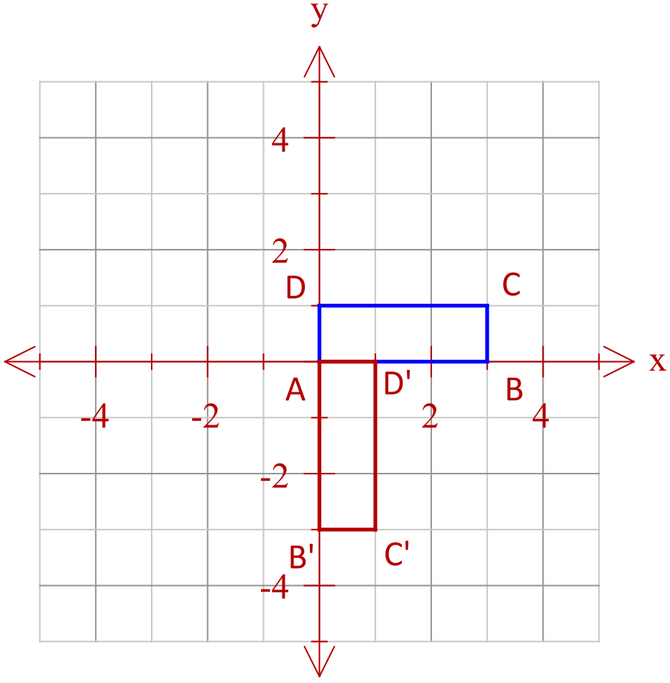

Rotation of 90˚ clockwise around the origin

c) Find A⁴. (1)

d) Explain, geometrically, the result of (c). (1)

4 applications of the matrix A, a 90˚ clockwise rotation about the origin results
in the image being returned to its original position

e) Find a 2x2 matrix which maps rectangle which maps ABCD to WXYZ with W(0,0) X(6,0) Y(6,3) and Z(0,3). (2)

Question 9 8 marks

A triangle with vertices at , and is to be reflected in the x-axis and then rotated anticlockwise about the origin.

a) Find the matrix that will combine these two transformations in the order given. (2)

b) Find the coordinates of after transformation by . (1)

C’(4,3)

c) Another transformation matrix is given by .

Determine the area of triangle A’’B’’C’’ after transformation by and then by . (3)

( or|T| = -1, |R| =0.36 )

New area =0.36 x original area
=0.36 x 3
= 1.08 sq units

e) Find the matrix which will transform A’’B’’C’’ to ABC. (2)

Matrix required is (RT) ⁻¹

Question 10 8 marks

On a normal Monday’s trading, BRASH’S Melville store sell, on average, the 8 televisions, 12 music systems and 6 digital video recorders. In comparison, the Cannington store sells, on average, 4 televisions, 9 music systems and 5 digital recorders.

a) Represent this information as the matrix S. (2)

T M D

b) The profits ($) on each item can be represented by matrix P, where P = (2)
Calculate SP.

What do the entries tell you?

The amount of profit at each stores on a normal Monday

For their MAD MONDAY SALE, profits were reduced by 40% and the following quantities sold.
Melville : 9 televisions, 8 music systems and 10 digital video recorders
Cannington : 8 televisions, 13 music systems and 15 digital video recorders

c) Use matrix operations to determine the overall increase or decrease in profit for the two stores on MAD MONDAY over a normal Monday. (4)

A decrease in profits of $750 (Dec of 780 Mel, Inc 830 Cann)

Question 11 3 marks

Find the image of the in line after it is reflected in the line .

